# Sophisticated Digital Effects

**Additional Options (Search)**

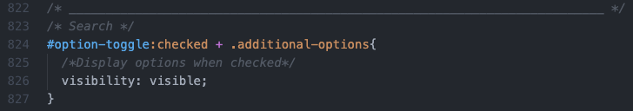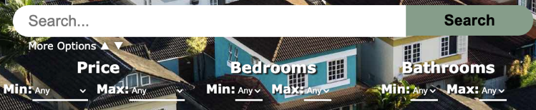I have added optional elements to my search bar that visibility can be toggled using an html checkbox. The checkbox is hidden but the associated label is visible so when the label is clicked it toggles the checkbox. This then controls the visibility of the additional options through CSS.

**Cards**

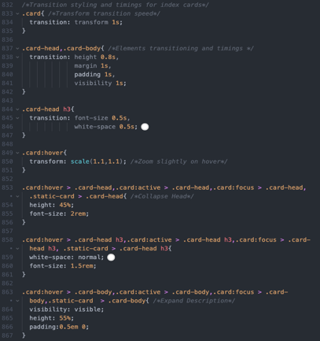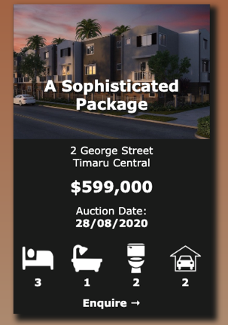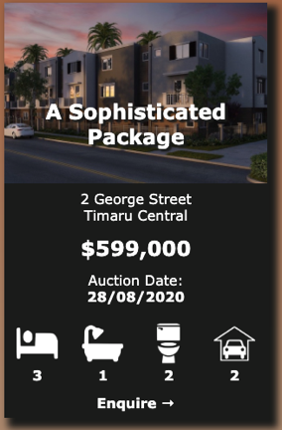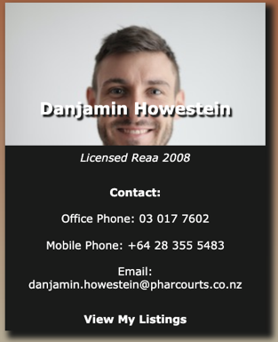I have several effects for my cards. For my Agent and Info cards they head takes up 100% of space and the body takes 0%. Then on hover the card ‘expands’ and the head retreats back while the body gets bigger to show the content of the card. I have also added a micro-animation that scales the card a small amount to emphasize the interaction between user and site. For some cards, such as my listing cards, they only have the transform and not the ‘expansion’ as it is more crucial the body information be always visible.

**Nav Items**

My nav items have a color and underline effect applied to them to signal interactivity to a user and an ‘active page’ styling which changes the color of the link to the page the user is currently on.

Normal: Hover:

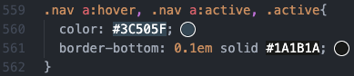Active:



# Applying Industry Standards or Guidelines

I have ensured that my code is valid by current standards through the use of the [W3C Verification Service](https://jigsaw.w3.org/). Here is the feedback from my results.

For my main style.css document I have used CSS variables and functions which is a much more recent addition to CSS than the validation can check for. This means that parse errors will be ‘thrown’ in the validator (502, 508, 512, 518) but in practice it is valid CSS code.

# Responsive Design For Use on Multiple Devices

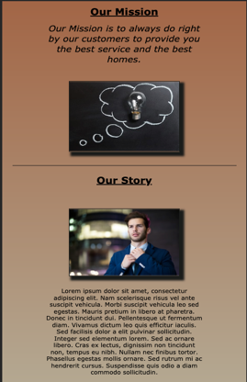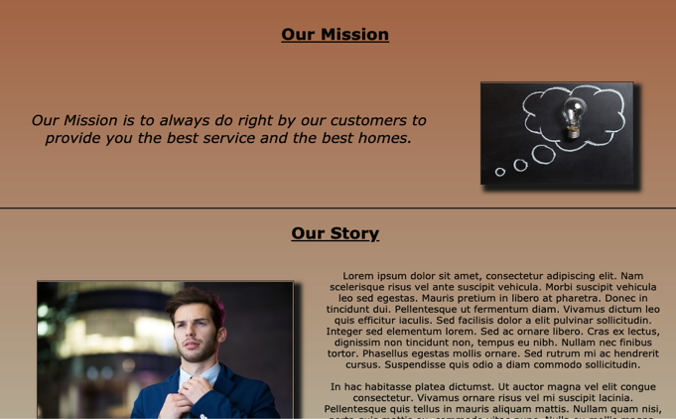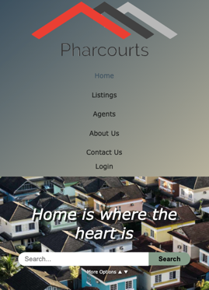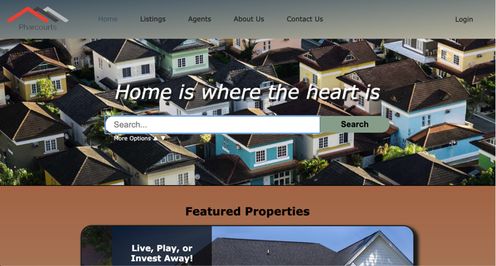I have used responsive units (percentages, em and rem) which dynamically adjust the sizing of elements based on the screen and font-size. Percentage is proportional to the attribute of the parent and em is proportional to the font-size of the parent. While rem is proportional to the font-size of the root. This allows me to set a root font-size and have the size and proportional of the page scale evenly allowing for page zoom and larger and smaller laptops without any loss of quality. I also have used media queries to, as the device gets much smaller (tablets/phones), change the font-size and layout of the page to make it fit onto the smaller device and have it usable. On laptops the design is very wide and uses the landscape display to it’s extent. However on a mobile device it is much smaller and portrait which means the layout of my page needs to switch to a vertical, more portrait layout

# Dynamic Data Handling and Interactivity

**Nav**

I have used dynamic data in the Navigation to switch the links contained in nav as well as Login/Logout based on the active user state. If no one is logged in then it will display the general links and Login but if someone is logged in it displays an Admin menu and Logout

General:

Admin:

**Title**

I applied dynamic data handling in a few places across my site. The first place is in ./inc/title.php which is the first main div on a page that displays the page name and additional content on a handful of other pages. How I have made this dynamic is every page includes the same title and file name of every page is the same as the text I want to display on most pages it simply displays the filename and the background image associated with that file name (if it exists). I have used a PHP switch statement to change the display text for special case pages such as index where it displays the slogan and listing-profile where it displays the address of the listing. There is also a second switch statement for additional content to add to the title such as a search bar to index and listing, or the contact details to the agent-profile. However, by default it is just an image and the name of the page. This allows me to include it on any page without changing any code and the content changes to match the current page

**Profiles**

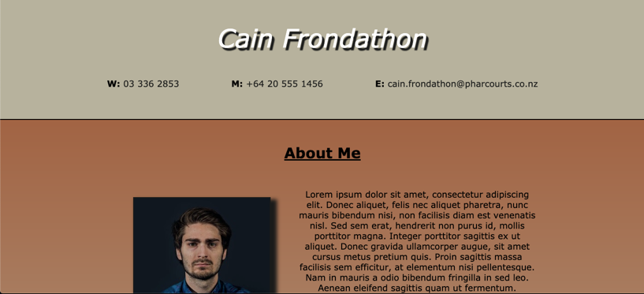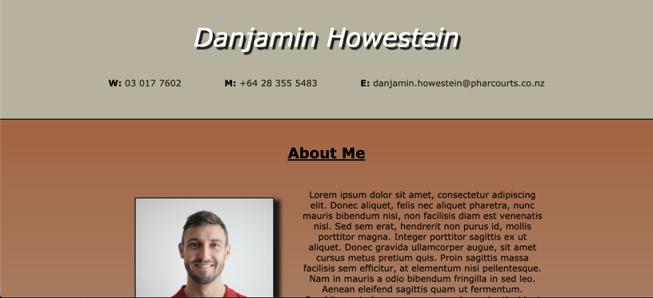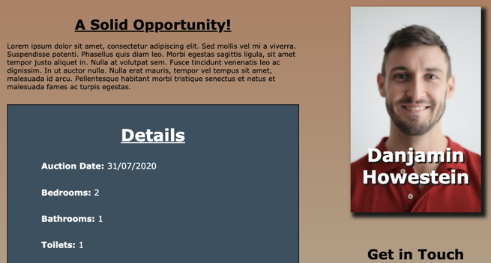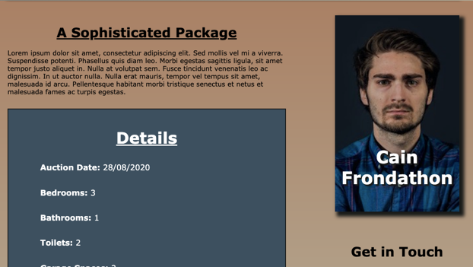I have also utilized dynamic data for my Listing and Agent profiles. These pages both have a template laid out but the content changes depending on what listing or agent has been clicked on. Each link to a listing or agent (from their cards) passes the ID of the listing/agent to the profile and then the page queries the required information and displays it accordingly. This mean I only need a single page for all of my listings and a single page for all of my agents. This creates consistency across the website, making it incredibly easy for a user to navigate and extremely easy for the developer to alter the layout etc. of the page as they only have to change a single page instead of a page for every listing and agent that exists.

# Automation Through Scripts

**Featured Properties and Testimonials**

I have used CSS keyframes to apply an automatic animation slider to my Featured Properties and Customer Testimonials sections on my Index Page and in my Footer. The original intent of these sections were to be manually controlled with JavaScript buttons but due to the inability of using JavaScript I have opted for an automatic scroll instead. This scroll takes a div containing (3) items with each item being 100% the width of the parent and overflowing to the right (this div is therefore 300% width of parent). Then using keyframes I alter the left positioning from 0 (first item) to -100% (second item) to -200% (third item) over a specified time before it resets back to 0. This causes the div to ‘slide’ transition between items to create the slideshow effect. This would be more effective if it was manually scrollable as it would give the user much more interactivity and the ability to read at their own pace 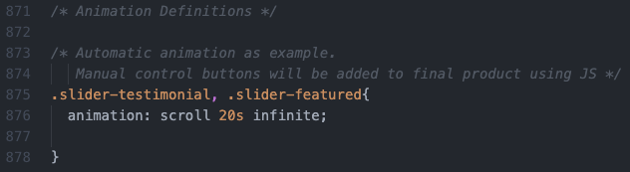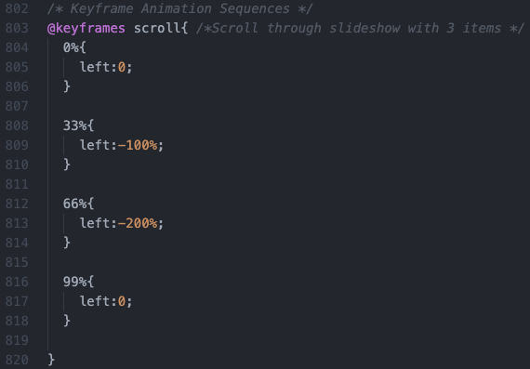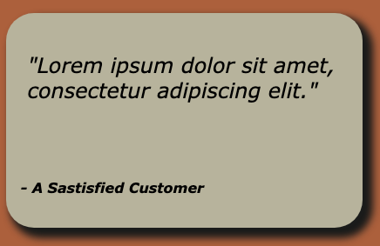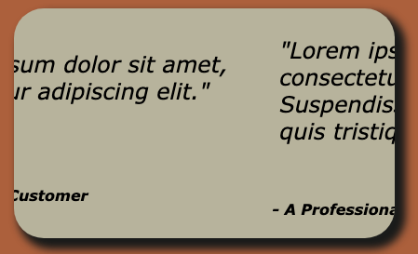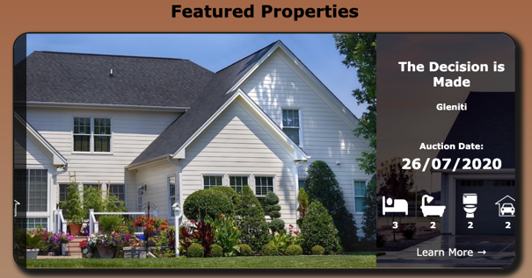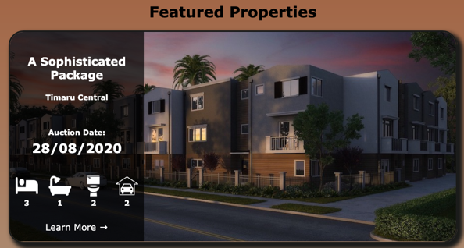however this serves as an adequate prototype for the final version.